**MongoDB ASSIGNMENT 4**

* **By Tushti Gupta SODS**
* 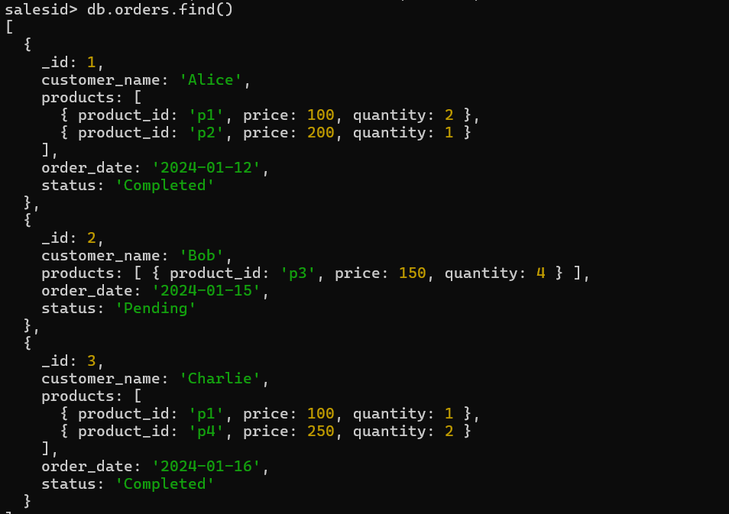**Creating Collection Orders in SalesId Database**
* Calculate Total Sales for Each Order.

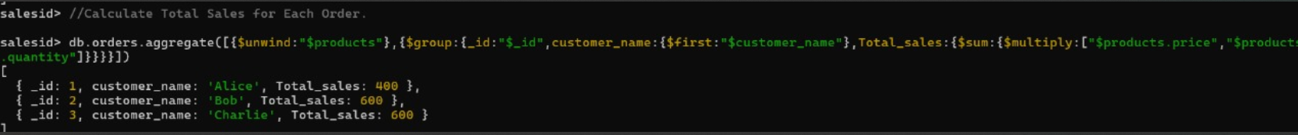

* **Calculate Average Order Value for Completed Orders.**



* Find the Maximum Quantity Sold per Product.

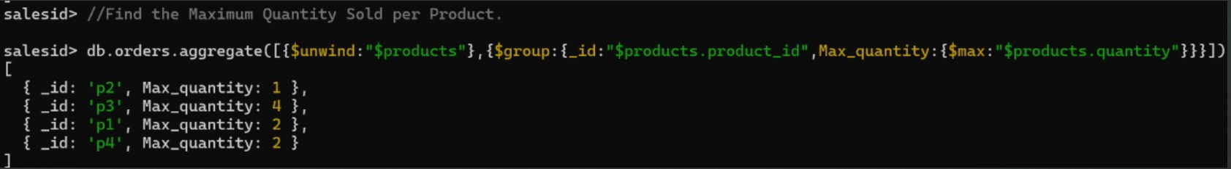

* Find Total Number of Orders for Each Status.

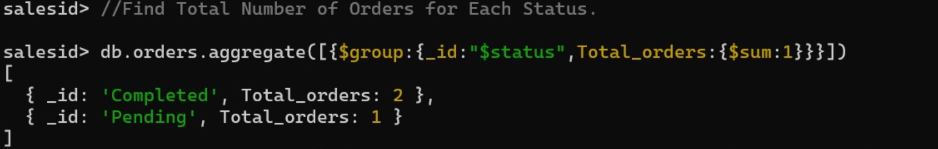

* Calculate Total Quantity of Products Sold Across All Orders.

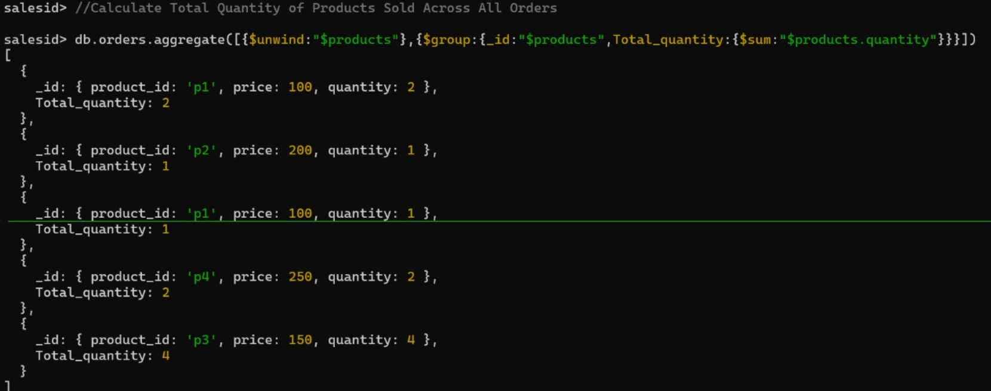

* **Get Minimum and Maximum Order Dates**

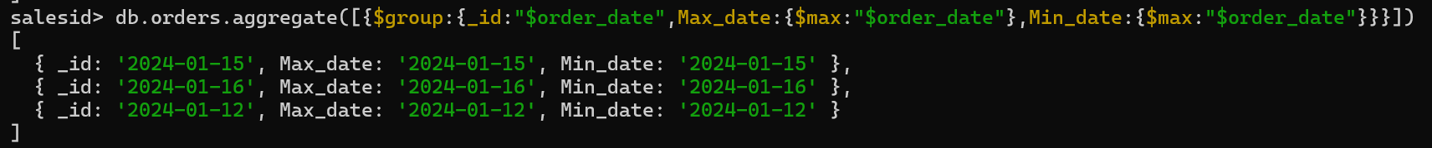

* Calculate the Total Number of Distinct Products Sold.

